

MCA Application Post Installation Configuration Guide

June 22, 2015

**Document History**

|  |  |  |  |
| --- | --- | --- | --- |
| **Version #** | **Author** | **Date (dd/mm/yyyy)** | **Comments** |
| 1.0 | Sneha Patil | 04.07.2014 | Initial Draft |
| 1.1 | Shraddha Patil | 23.07.2014 | New enhancement in the application. |
| 1.2 | Ripal Patel | 22.06.2015 | New enhancement in the application. |

**Table of Contents**

**1 INTRODUCTION 3**

**2 PREREQUISITES 4**

**3 LEAD MAPPINGS 5**

**4 PAGE LAYOUT ASSIGNMENTS _ 6**

**5 LEAD RATING FORMULA ON LEAD 8**

**6 OPPORTUNITY CONTACT ROLE 10**

**7 CUSTOM SETTING CONFIGURATION 11**

**8 CONFIGURE CUSTOM LABELS 16**

8.1 ENABLE TRANSLATIONS FOR THE ORG 25

**9 CREATE RECORD FOR SUBMISSION MAIL DETAIL OBJECT 27**

**10 CREATE A DOCUMENT RECORD (OPTIONAL) TO DISPLAY IMAGE IN SUBMISSION EMAIL** **30**

10.1 CHANGE ACCESS LEVEL TO ALL EMAIL FOR THE ORG **31**

**11 SET FUNDING APPLICATION AS A DEFAULT APP _ 32**

**12 OPPORTUNITY STAGE FIELD CHANGES 33**

12.1 ADD PICK-LIST VALUE ON “TYPE” FIELD FOR OPPORTUNITY **33**

**13 CONFIGURE CUSTOM SETTINGS FOR OPPORTUNITY IMAGE BAR 34**

**14 CONGA TEMPLATE CONFIGURATION 35**

**15** **CONGA EMAIL TEMPLATE CONFIGURATION 36**

**16 CONGA QUERIES CONFIGURATION 37**

# **Introduction**

* MCA Application Configuration Guide is designed to provide the steps that need to be configured after installation of the MCA Application. It also provides the pre-requisites required for the MCA application configuration.
* This manual can help you to fix the required post installation configuration settings for MCA application to achieve the effective and efficient performance of the MCA application.

# **Prerequisites**

|  |  |  |
| --- | --- | --- |
| **Sr. No.** | **Item** | **Description** |
| 1 | MCA Installation | Install the MCA application using the provided URL. |
| 2 | Conga Installation | Install the Conga Composer from App Exchange. |
| 3 | Lead Scoring Rule | Install the Lead Scoring Rule application from App Exchange. |
| 4 | Activity Manager | Install the Activity Manager application from App Exchange. |
| 5 | Lets Talk About The Weather | Install the Lets Talk About The Weather application from AppExchange. |

# 3 **Lead Mappings**

* + Map the fields on Lead as given in Table 1*.*

**Table 1 – Lead Mapping Fields**

|  |  |  |  |
| --- | --- | --- | --- |
| **Sr. No.** | **Lead Fields** | **Fields to Map** | **Object** |
| 1 | Average Monthly CC Sale | Monthly CC Avg | Account |
| 2 | Convert | ConvertedAccount | Account |
| 3 | Credit Score | Credit Score | Opportunity |
| 4 | Desired Amount | Amount Requested | Opportunity |
| 5 | ISO | ISO | Opportunity |
| 6 | ISO Sales Rep | ISO Sales Rep | Opportunity |
| 7 | Lead Created Date (Copy for Mapping) | Lead Created Date | Opportunity |
| 8 | Monthly Gross Sales | Gross Monthly Sales | Account |
| 9 | Set Opportunity Status | Set Opportunity Status | Opportunity |
| 10 | Total Lead Score | Lead Score at Conversion | Opportunity |
| 11 | Years in Business | Years In Business | Account |

# 4 **Page Layout Assignments**

* + Page Layout need to configure.

**Table 2 – Object Page Layout**

|  |  |  |  |
| --- | --- | --- | --- |
| **Sr. No.** | **Page Layout** | **Object** | **Description** |
| 1 | Merchant | Account | Assign **Merchant** Page Layout as a Master Page Layout for the Account object. |
| 2 | Lead Layout | Lead | Default Lead Page Layout from MCA package will be act as Master Page Layout for the Lead object. |
| 3 | Opportunity Layout | Opportunity | Default Opportunity Page Layout from MCA package will be act as Master Page Layout for the Opportunity object. |
| 4 | Contact Layout | Contact | Default Contact Page Layout from MCA package will be act as Master Page Layout for the Contact object. |
| 5 | Contract Layout | Contract | Default Contract Page Layout from MCA package will be act as Master Page Layout for the Contract object. |

* + By default managed package page layout are not assigned to all objects, therefore manually we have to assign packaged page layouts by going through below mentioned steps:-

1. To assign **Page Layout** to the Opportunity, Contact, Account, Contract, Lead objects
   1. Click on the **Setup** menu.
   2. Click on **Customize > Object name > Page Layouts.**

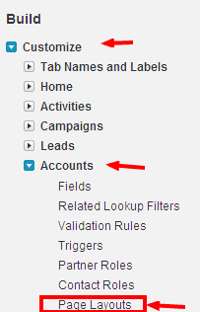

**Figure 1 – Customize Page Layouts**

* 1. Click on the **Page Layout Assignment** tab > Edit Assignment.
  2. Click on the Profile, to select the profile on which you need to assign the packaged page layout. If you want to select multiple profile simultaneously, you need to press ctrl +click on that profile. After selection the profile it will display as shown in the Figure 2*.*

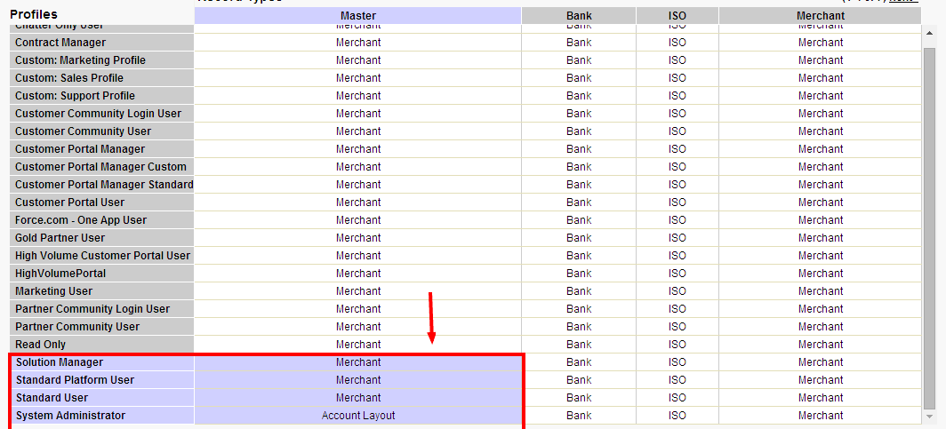

**Figure 2 – Page Layout Edit Assignment for Standard Object**

* 1. Click on **Save** after assigning the profiles and perform a quick round of testing by navigating through **Object** tab > Click on any record > check the Layout.

1. For all other Objects:
   1. Click on **Create > Object >** select the object for which Page Layout need to assign.
   2. Go to the **Page Layout** section and click on **Page Layout Assignment** tab as shown in Figure 3*.*
   3. Follow the steps as described on 1.3 and 1.4.



**Figure 3 – Page Layout Edit Assignment for Custom Object**

1. Merge Page Layout for Standard objects
   1. Click on the **Setup** menu.
   2. Click on **Customize > Object name > Page Layouts.**
   3. To merge Page layout, either add existing fields to MCA page layout or add MCA field to existing standard page layout. OR you can create Legacy structure in which you need to create legacy record type and assign existing standard page layout to it which holds old records of the Standard object.

# 5 **Lead Rating Formula on Lead**

* If the “Lead Scoring App” is installed in your org, then only this step is required, otherwise skip this step.
* To create a lead rating field, go to below mentioned steps

1. Go to **Setup > Customize > Lead > Fields > New.**
2. Select the Data Type **Formula** and click Next.

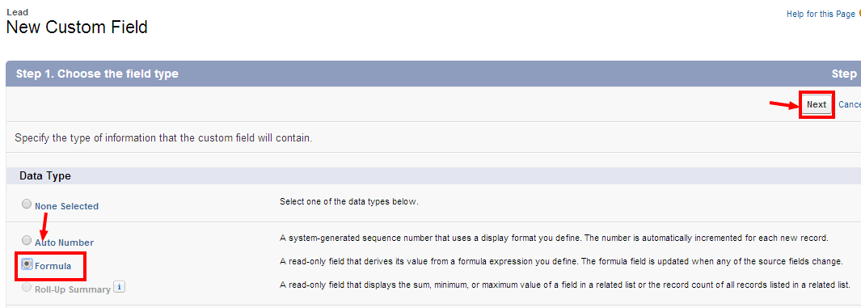

**Figure 4 – Field Type Selection Wizard**

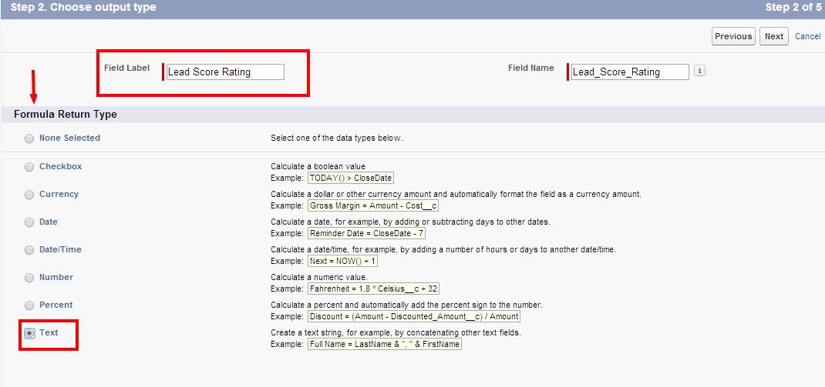

**Figure 5 – Field Output Type Selection Wizard**

1. Type the Field Label as **“Lead Score Rating”** and select Formula Return Type as **“Text”.**
2. Click Next and write the below logic inside the **Formula Editor** as shown in Figure 6.

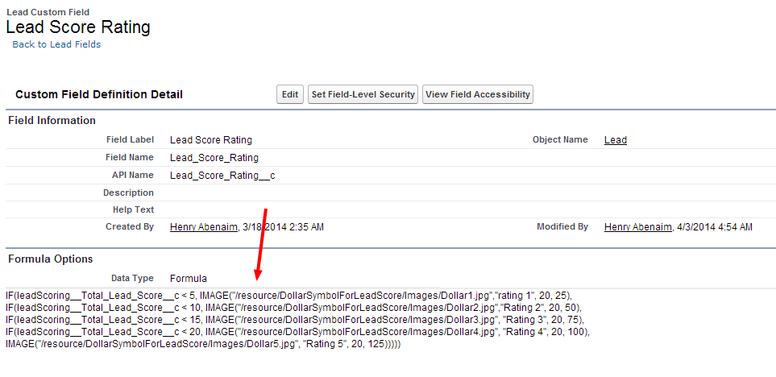

**Figure 6 – Formula Editor**

**Formula for Lead Score rating:**

IF(leadScoring__Total_Lead_Score__c < 5, IMAGE("/resource/MCAApp__DollarSymbolForLeadScore/Images/Dollar1.jpg","rating 1", 20, 25),

IF(leadScoring__Total_Lead_Score__c < 10, IMAGE("/resource/MCAApp__DollarSymbolForLeadScore/Images/Dollar2.jpg","Rating 2", 20, 50),

IF(leadScoring__Total_Lead_Score__c < 15, IMAGE("/resource/MCAApp__DollarSymbolForLeadScore/Images/Dollar3.jpg", "Rating 3", 20, 75),

IF(leadScoring__Total_Lead_Score__c < 20, IMAGE("/resource/MCAApp__DollarSymbolForLeadScore/Images/Dollar4.jpg", "Rating 4", 20, 100),

IMAGE("/resource/MCAApp__DollarSymbolForLeadScore/Images/Dollar5.jpg", "Rating 5", 20, 125)))))

1. Click **Next > Next > Save**.

# 6 **Opportunity Contact Role**

* Create Business owner role and mark it as **“Default”.**

1. Click on **Setup > Customize > Opportunity > Contact Roles > New.**
2. Create a new role as **“Business Owner”** and mark it as **“Default”.**

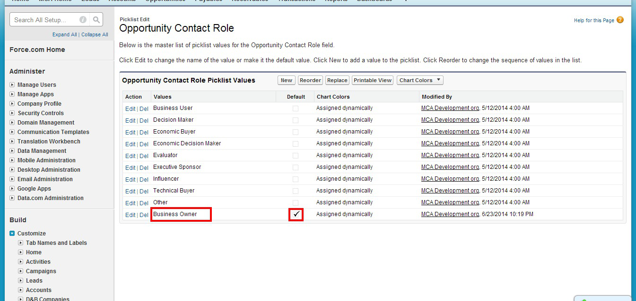

**Figure 7 – Opportunity Contact Role**

# 7 **Custom Setting Configuration**

Configure following Custom Settings:

* **Payables/ Receivables Status**
* Custom Setting Stores the Status of the Payables and Receivables (Transaction Line Items) which are not to be displayed on the Transaction while creating Line Items.
* Steps to create Custom Setting Record:

1. Click on the **Setup** menu and then click on the **Custom Setting.**
2. Click on the **Payables/ Receivables Status Setting.**
3. Click on **Manage** button.
4. Create two records as shown below with Name as:
   1. Cancelled
   2. Paid

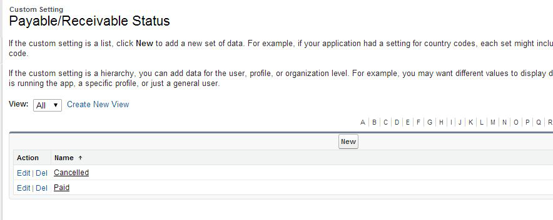

**Figure 8 – Status of the Payable/ Receivable which are not displayed while creating Transaction**

* **Admin Accounting Setting**
* Stores the Values that are displayed on the Admin Page Accounting Section:
  + **Name** – Stores the Label that is to be displayed on the Accounting section of Admin Page.
  + **URL** – Stores Partial(only id) or complete URL of the link which opens on the click of the Link.
* Steps to create Custom Setting data:

1. Click on the **Setup** menu and then click on the **Custom Setting.**
2. Click on the **Manage** of Admin Accounting Setting.

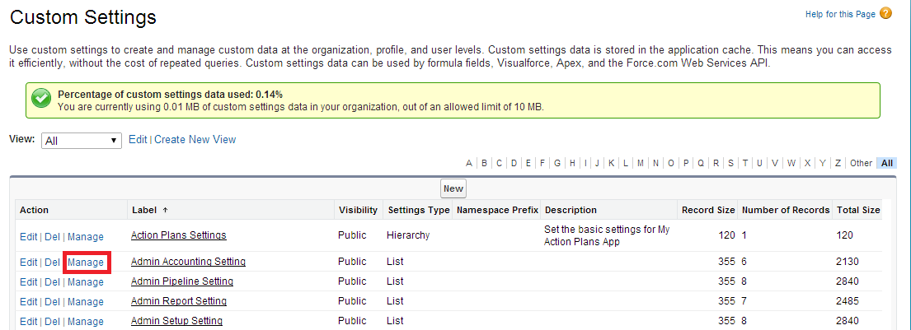

**Figure 9 – Manage on Admin Accounting Setting**

1. Click on **New** field.
2. Create record with Name and the URL of the value that is to be displayed on the Accounting column of Admin Page as shown in *Figure 11.*

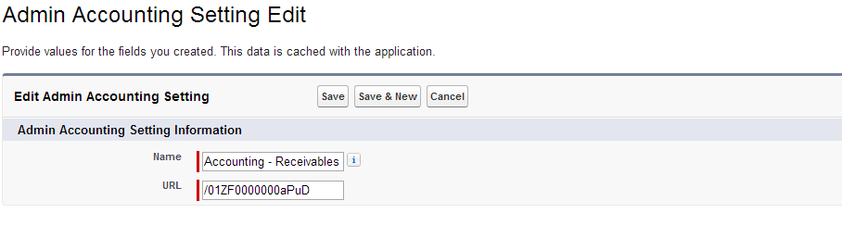

**Figure 10 –Create Admin Accounting Setting Record**

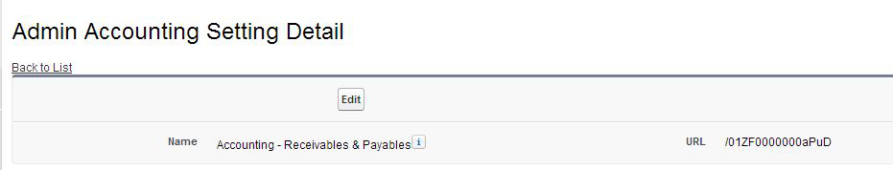

**Figure 11 – Record for Admin Accounting Setting**

* Similarly create data for all the following values:

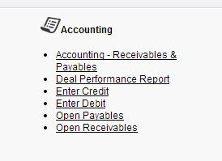

**Figure 12 – Accounting Section on Admin Page**

* **Admin Report Setting**
* Stores the values that are to be displayed on Report Section of Admin Page.
  + **Name** – Stores the Label that is to be displayed on the Admin Page.
  + **URL** – Stores Partial or complete URL of the link which opens on the click of the Link.
* Steps to create Custom Setting data:

1. Click on the **Setup** menu and then click on the **Custom Setting**.
2. Click on **Manage** of Admin Report Setting.
3. Click on **New** Button.
4. Create records for all the following data with Name and the URL of the value that is to be displayed on Report column of Admin Page.

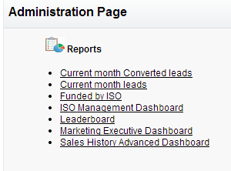

**Figure 13 – Report Section of Admin Page**

* **Admin Pipeline Setting**
* Similar to Admin setting populate this setting with the values that are to be displayed on Pipeline section of Admin Page.
* **Admin Setup Setting**
* Similar to Admin setting populate this setting with the values that are to be displayed on Setup section of Admin Page.
* **FundingApplicationPage_ShowCongaButton**
* Stores if the Email PDF and Create PDF button on funding Application should be visible or not on the funding Application.
  + **Name –** Stores the Name of the Button on the Funding Application.
  + **Active** – Checkbox stores whether to display the button on the Funding Application Page (It should be Active if Conga is available in the org, else the Active checkbox should be false).
* Steps to create data:

1. Click on the **Setup** menu and then click on the **Custom Setting.**
2. Click on **Manage** of FundingApplicationPage_ShowCongaButton setting.
3. Click on **New** button.
4. Create following Data:
   1. Create PDF
   2. Email PDF

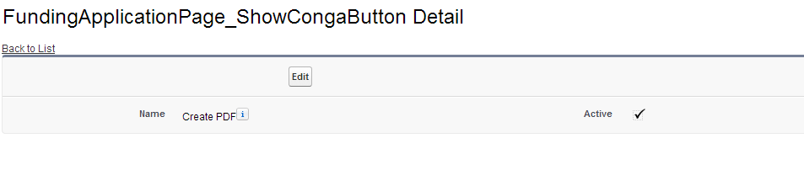

**Figure 14 – Create PDF data for Custom Setting**

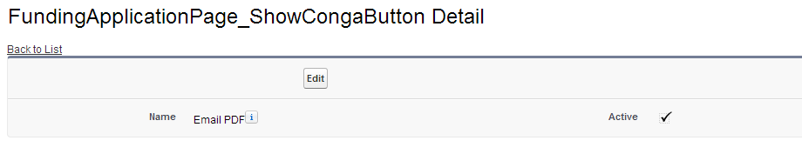

**Figure 15 – Email PDF data for Custom Setting**

* **Excluded Subjects**
* Add records to ExcludedSubjects custom setting by using Manage button.
* This will exclude count of Activities on Lead having subject name as mentioned in ExcludedSubjects custom setting.

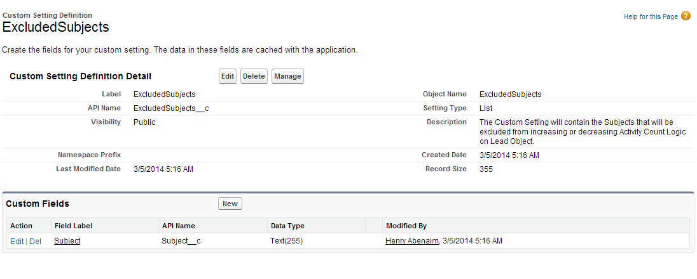

**Figure 16 – Excluded Details Custom Settings**

# 8 **Configure Custom Labels**

* **BankListId**
* Stores the List View Id of Bank list view on Account.
* Steps to capture the ID:

1. Click on **Accounts** Tab.
2. Select **Banks** from View drop down list.

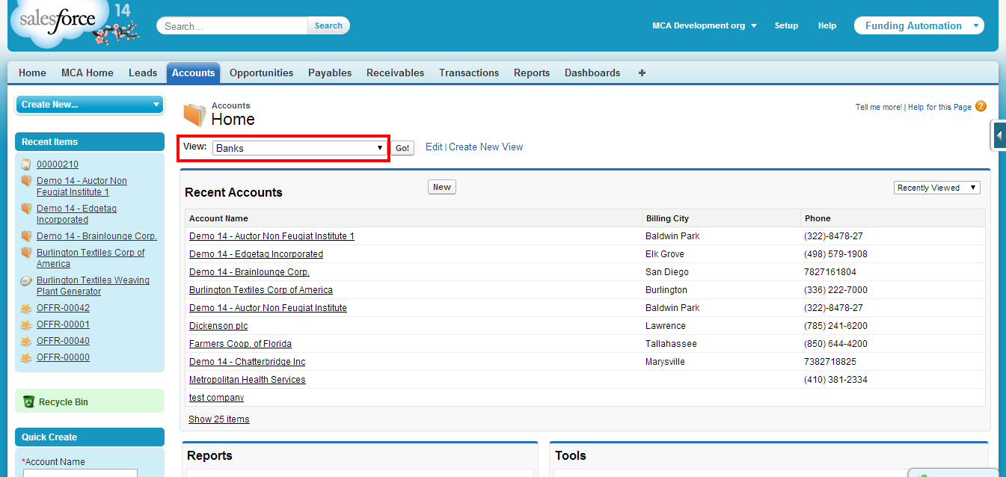

**Figure 17 – Bank List View on Account**

1. Click **Edit** button.

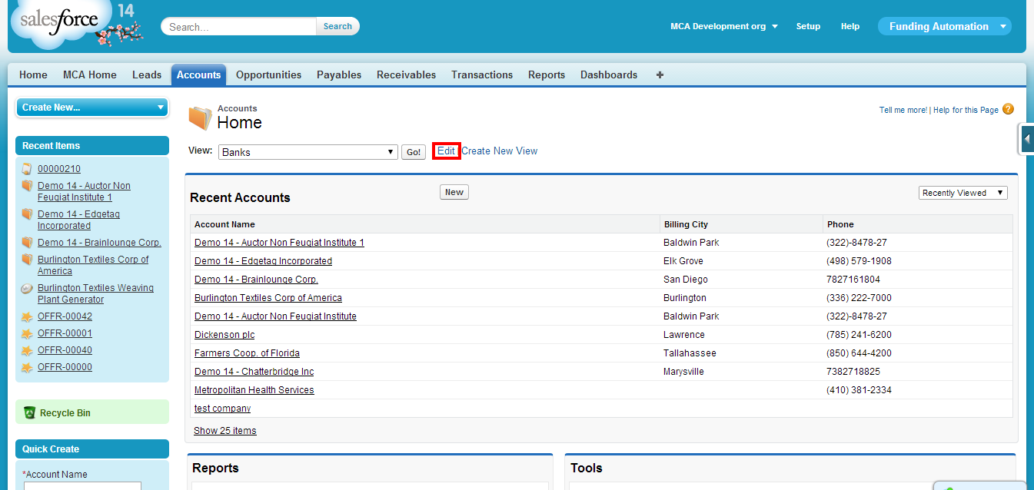

**Figure 18 – Edit button on Bank List View**

1. Copy the **ID** as shown in Figure 19*.*

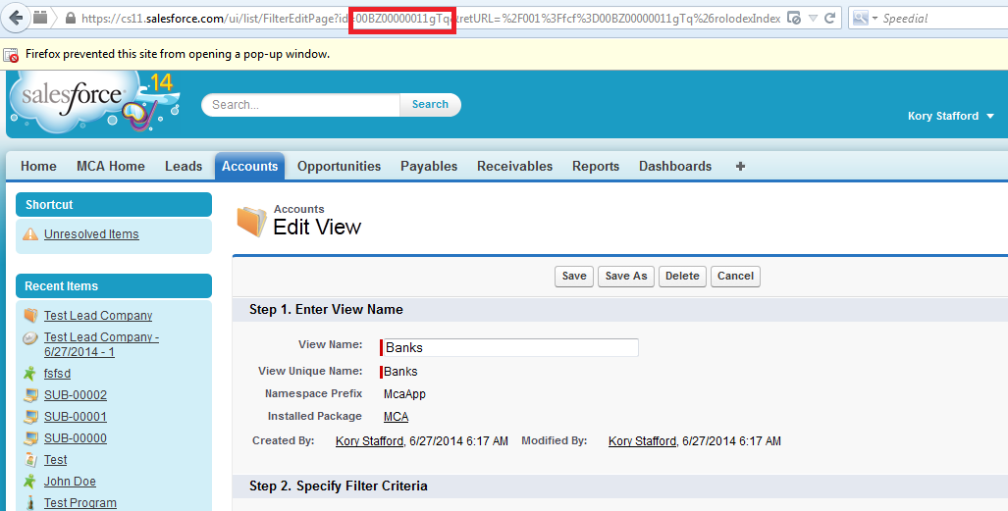

**Figure 19 – Copy the ID of Bank List View**

1. Click on the **Custom Label** and then click on **BankListId** label.
2. Click on **New Local Translations/ Overrides** and paste the ID as shown in Figure 20*.*

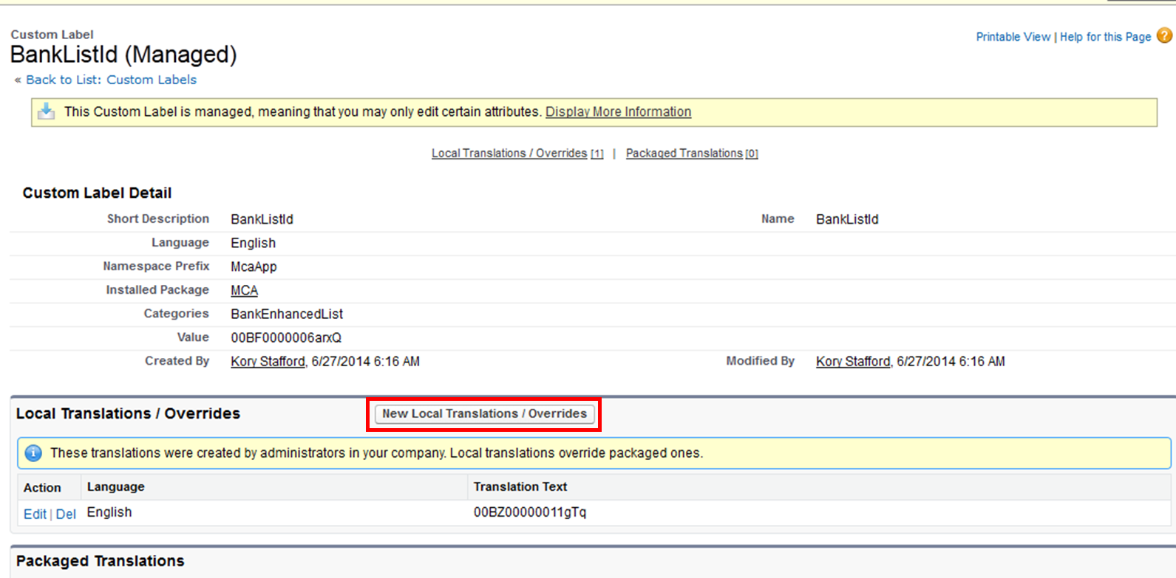

**Figure 20 – BankListId Label with the New Value**

* **ISOListId**
* Stores the List View ID of ISO list view on Account Steps to capture the ID.
* Similar to Bank List view ID, capture the ISO list view Id and store it in ISOListId Custom Label.

* **DashboardIdeas_CampaignsUrl**
* Stores the ID of the component that is displayed on MCA Home Campaign link. The component that is displayed is Campaign Metrics Dashboard.
* Steps to populate the Label

1. Click on **Dashboards** tab.
2. Go to the folder **Campaign Dashboard.**
3. Click on **Campaign Metrics Dashboard.**
4. Copy the ID of the dashboard.
5. Go to custom Labels, open DashboardIdeas_Campaigns URL label.
6. Click on 'New Local Translations / Overrides' and paste the ID.

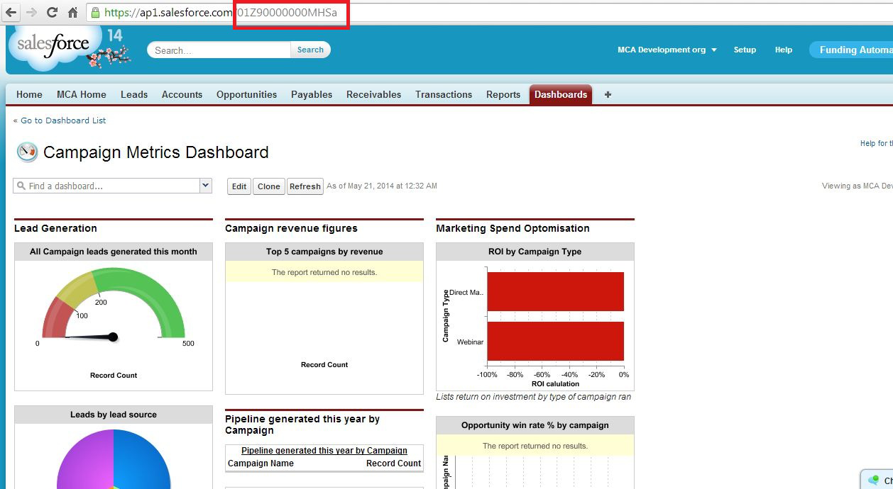

**Figure 21 – ID of Campaign Metrics Dashboard**

* **DashboardIdeas_Lead**
* Stores the Id of the component that is displayed on MCA Home Lead image link. The component that is displayed is Leads Management Dashboard.
* Similar to the above label store the Id of Leads Management Dashboard in DashboardIdeas_Lead label.

* **DashboardIdeas_DealsDashboard**
* Stores the Id of the component that is displayed on MCA Home Deals image link .The component that is displayed is Deal Management Dashboard.
* Similar to the above label store the Id of Deal Management Dashboard in DashboardIdeas_ DealsDashboard

* **Dashbaord_Renewal_Path_Url**
* Stores the partial URL of the component that is displayed on MCA Home Renewals image link. The component that is displayed is Manage Renewal Page.

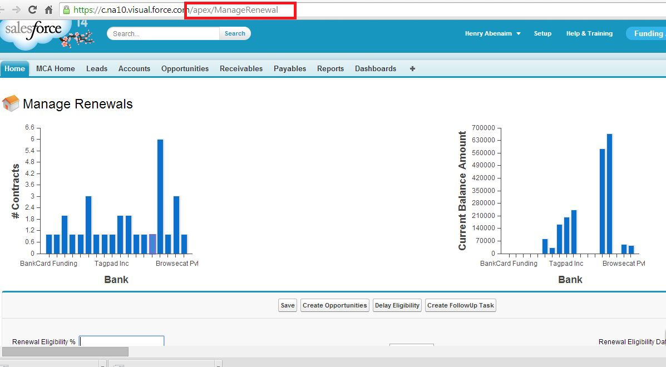

**Figure 22 – Partial URL for Manage Renewal Page**

* **DashbaordIdeas_Commissions_Path_Url**
* Stores the Id the component that is to be displayed on MCA Home Commissions image link. The component that is displayed is Accounting – Receivables & Payables Dashboard.
* Store the Id of Accounting – Receivables & Payables Dashboard in the label.
* **DashboardIdeas_Syndication_Dashboard**
* Stores the Id the component that is to be displayed on MCA Home Syndication image link. The component that is displayed is Syndication Dashboard.
* Store the Id of Syndication Dashboard in the label.
* **DashbaordIdeas_Dashboard_Path_Url**
* Stores the Id the component that is to be displayed on MCA Home Dashboards image link. The component that is displayed is Company Performance Dashboard.
* Store the Id of Company Performance Dashboard in the label.
* **DashboardIdeas_MyInbox**
* Stores the Id the component that is to be displayed on MCA Home My Inbox image link.
* Store the URL of Activities Page if the Activities Package exist else add the home Page URL in the label.
* **DashboardIdeas_Admin**
* Stores the partial URL of the component that is displayed on MCA Home Admin image link. The component that is displayed is Admin Page.

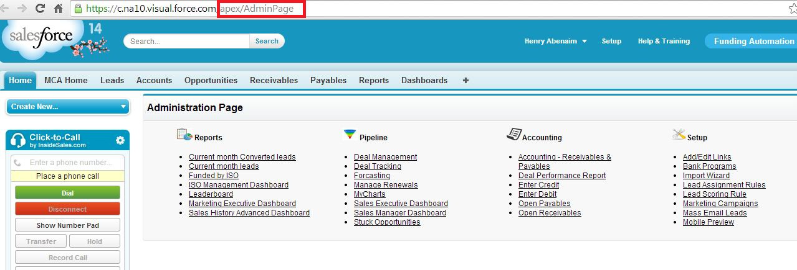

**Figure 23 – Partial URL for Admin Page**

* **MCA_Home_Task_Activities_Management_Dashboard**
* Stores the Id the component that is to be displayed on MCA Home Tasks image link. The component that is displayed is Sales activity dashboard
* Store the Id of Sales activity dashboard in the label.

* **Email_Stips_Template_Id**
* Stores the Id the Email Stips Visualforce Email Template.
* Steps:

1. Go to Visualforce Email template.
2. Open Email Stips template.
3. Copy the ID of the template.
4. Paste it to Email_Stips_Template_Id label.

* **FundingApplicationTemplateId**
* Add the ID of Funding Application Conga template.

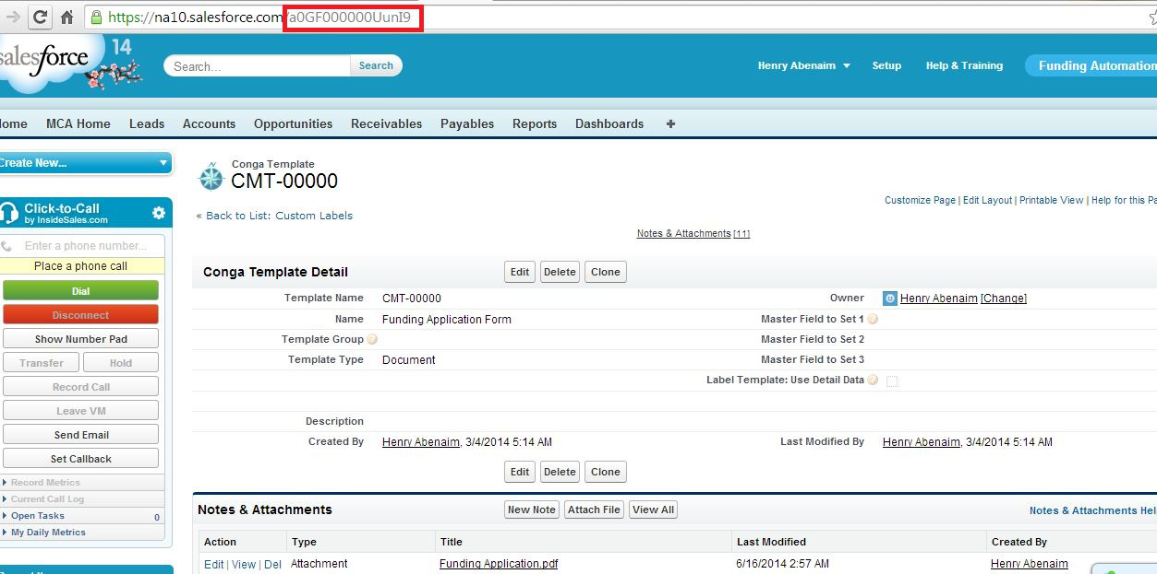

**Figure 24 – Funding Application Template ID**

* **CongaTemplateId**
* Stores the Funding Application Email Template ID.

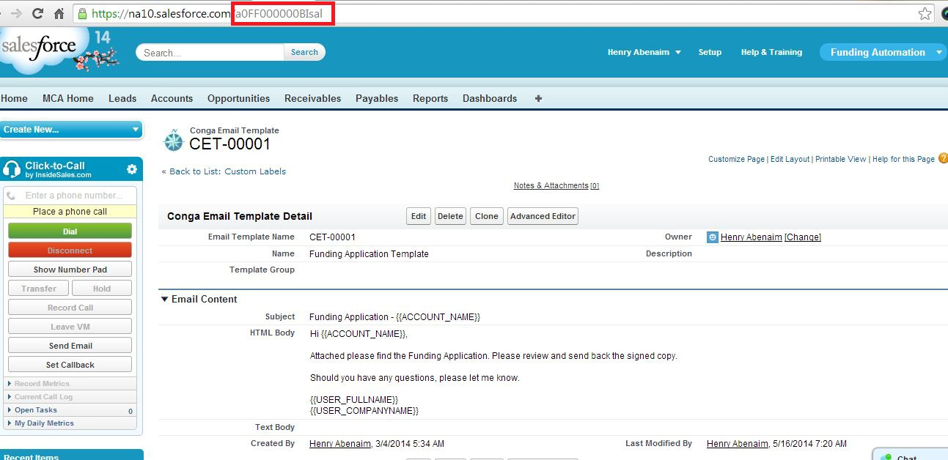

**Figure 25 – Funding Application Conga Email Template ID**

* **CongaQueryId_Offer**
* Store the ID Conga Query named Offer.

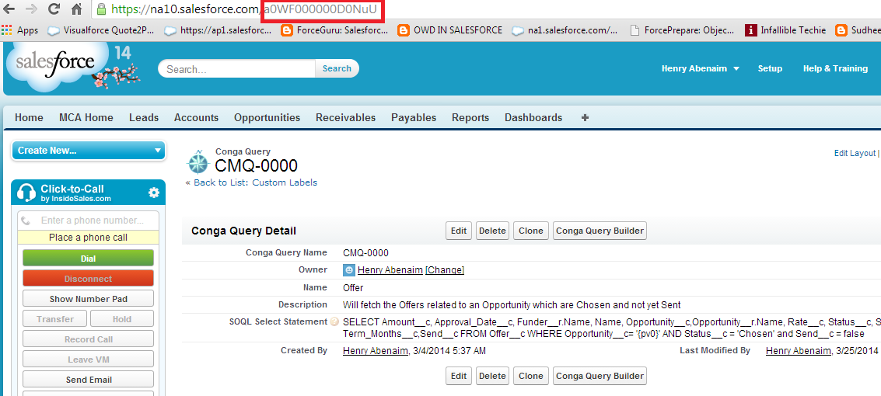

**Figure 26 – Conga Query for Offer**

* **CongaEmailTemplate_Offer**
* Stores the Id of the Conga Email Template Offer.

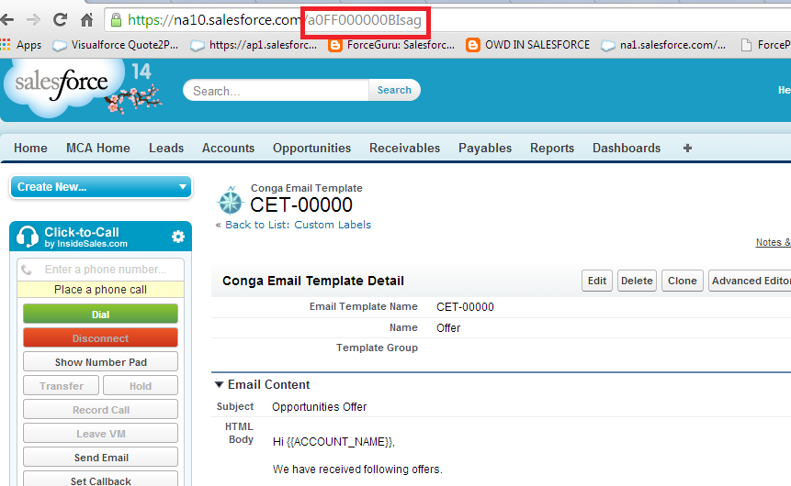

**Figure 27 – Conga Email Template for Offer**

* **SubmissionWizard_LogoName(Optional) -**
* Put the name of **Document Name** (e.g. Here in above image Document Name is specified as Submission Email Logo, which is mentioned as a value in ubmissionWizard_LogoName value) in value of **SubmissionWizard_LogoName** custom Label.

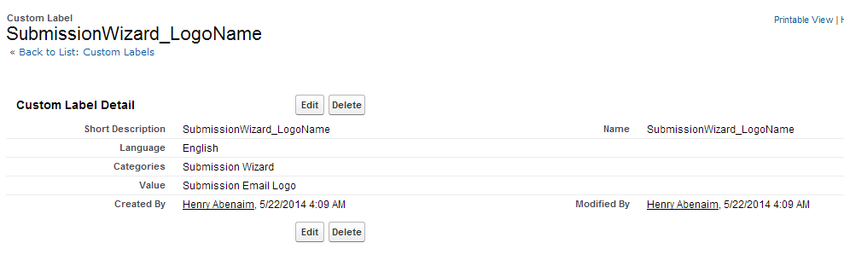

**Figure 28 – Label for Submission Wizard Logo**

* **MCAHome_TotalFundedThisMonth -** 
  + Stores the id ofOpportunity list view “Total Funded this month”
  + Steps to capture the list view ID

1. Click on Opportunity tab
2. Select the “Total Funded this month” list view from drop down.

**Figure – Total Funded this month List View on Opportunity**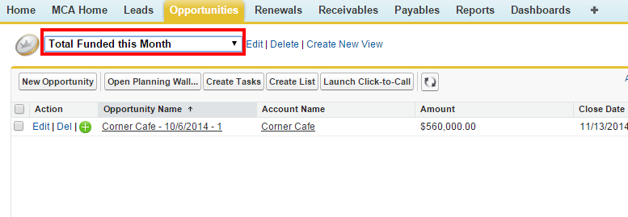

1. Click on **Edit**

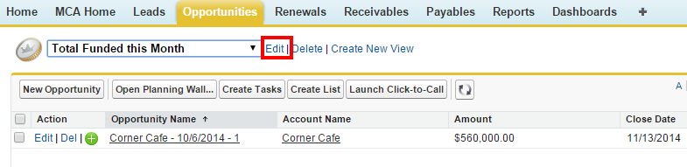

**Figure - Edit button of Total Funded this month List View**

1. Copy the **ID** as shown in below Figure*.*

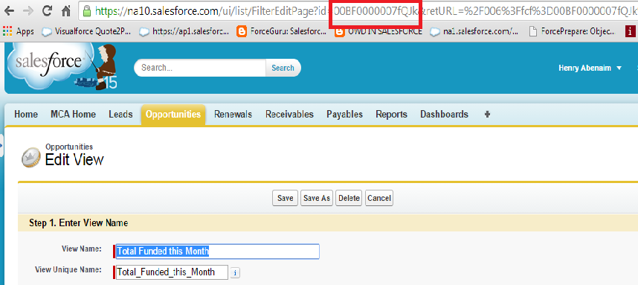

**Figure - Copy the ID of Total Funded this month List View**

1. Click on the **Custom Label** and then click on **MCAHome_TotalFundedThisMonth** label
2. Click on **New Local Translations/ Overrides** and paste the ID as shown in Figure 20*.*

* **MCAHome_DealsOnHold**
  + Stores the ID of Opportunity list view **“# Deals on Hold”**
  + Refer the above steps to get the ID of “# Deals on Hold” list view and store it in **MCAHome_DealsOnHold** custom label
* **MCAHome_DealsInUnderwriting**
  + Stores the ID of Opportunity list view **“# Deals in Underwriting”**
  + Refer the above steps to get the ID of “# Deals in Underwriting” list view and store it in **MCAHome_DealsInUnderwriting** custom label
* **MCaHome_LeadsThisWeek**
  + stores the ID of Opportunity list view **“# New Leads This Week”**
  + Refer the above steps to get the ID of “# New Leads This Week” list view and store it in **MCaHome_LeadsThisWeek** custom label
* **MCAHome_DealsInAproval**
  + Stores the ID of Opportunity list view **“# Deals In Approval”**
  + Refer the above steps to get the ID of “# Deals In Approval” list view and store it in **MCAHome_DealsInAproval** custom label
* **MCAHome_DealsInAppSent**
  + Stores the ID of Opportunity list view **“# Deals In App Sent”**
  + Refer the above steps to get the ID of “# Deals In App Sent” list view and store it in **MCAHome_DealsInAppSent** custom label
* **MCAHome_DealsInSignedAgreement**
  + stores the ID of Opportunity list view **“# Deals In Signed Contact”**
  + Refer the above steps to get the ID of **“**# Deals In Signed Contact**”** list view and store it in **MCAHome_DealsInSignedAgreement** custom label
* **MCAHomeChart_OpportunityPipeline**
  + Stored the ID of report “Opportunity by Stage”
  + Steps to capture ID org report

1. Click on Reports tab
2. Select the “Opportunity by Stage” report from search window as shown in below Figure

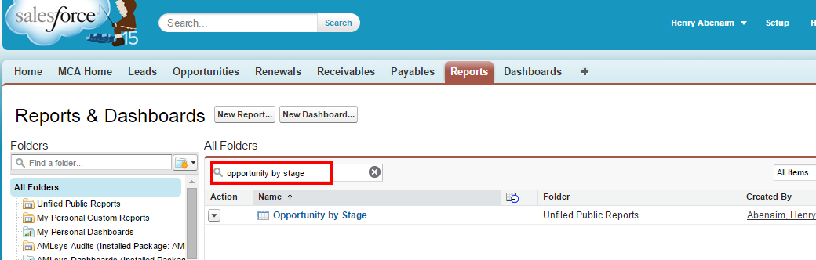

**Figure - Search for report**

1. Click on the searched report.
2. Copy the **ID** of selected report as shown in Figure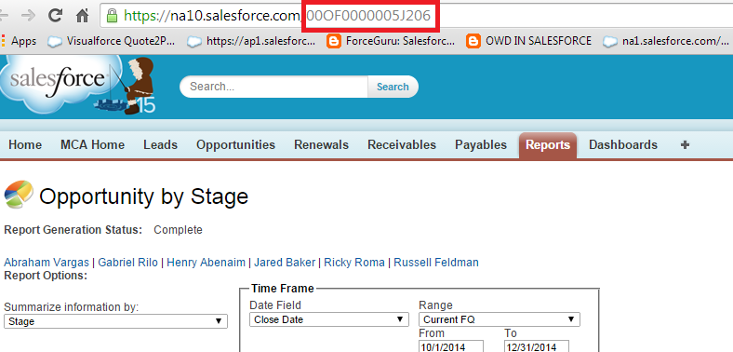

**Figure - Copy the report ID from URL**

1. Click on the **Custom Label** and then click **MCAHomeChart_OpportunityPipeline** label
2. Click on **New Local Translations/ Overrides** and paste the ID as shown Figure 20*.*

* **MCAHomeChart_FundedMTD**
  + stores the ID of report **“Funded MTD”**
  + Refer the above steps to get the ID of“Funded MTD” report and store it in **MCAHomeChart_FundedMTD** custom label
* **MCAHomeChart_AppSendtoReceived**
  + stores the ID of report **“App Sent to App Received”**
  + Refer the above steps to get the ID of “App Sent to App Received” report and store it in **MCAHomeChart_AppSendtoReceived** custom label
* **MCAHomeChart_FundedEligibility**
  + stores the ID of report **“Funded Renewal Eligibility”**
  + Refer the above steps to get the ID of “Funded Renewal Eligibility” report and store it in **MCAHomeChart_FundedEligibility** custom label
* **FundingAppForm**
  + stores the URL of  **“Funding Application Page ” i.e**

**/apex/McaFundingApp__FundingApplication?**

* **Report1**
  + stores the ID of report **“Bank with Opportunity Count”**
  + Refer the above steps to get the ID of “Bank with Opportunity Count” report and store it in **Report1** custom label
* **Report2**
  + stores the ID of report **“Funded Renewal Eligibility-Opportunites”**
  + Refer the above steps to get the ID of “Funded Renewal Eligibility-Opportunites” report and store it in **Report2** custom label
* **Report3**
  + stores the ID of report **“Opportunity Count by Terms Month”**
  + Refer the above steps to get the ID of “Opportunity Count by Terms Month” report and store it in **Report3** custom label
* **MCAHome_AppReceivedView**
  + Stores the ID of Opportunity list view **“Application In”**
  + Refer the above steps to get the ID of “Application In” list view and store it in **MCAHome_AppReceivedView** custom label
* **MCAHome_ContractSentView**
  + Stores the ID of Opportunity list view **“Agreement Sent”**
  + Refer the above steps to get the ID of “Agreement Sent” list view and store it in **MCAHome_ContractSentView** custom label

## 8.1 **Enable Translations for the Org**

To enable the translations for the Org follow the steps as given below:

1. Go to **Translation settings** from Setup as shown in Figure 29*.*

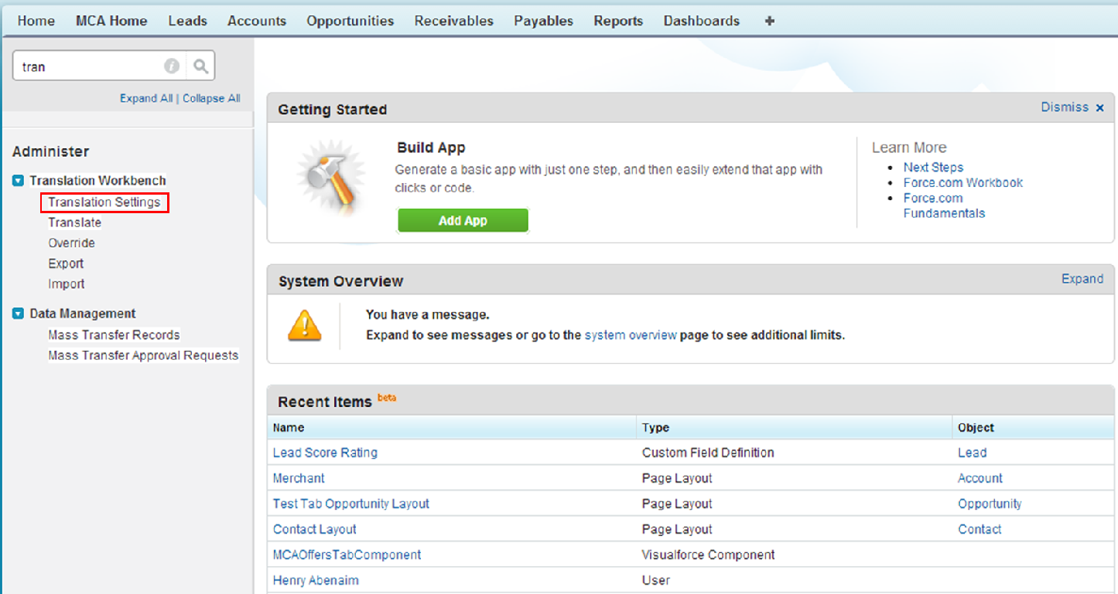

**Figure 29 – Go to Translation Settings from Setup**

1. Check if the **Translation Workbench** is enabled, if not click on **Enable** button as shown in Figure 30*.*

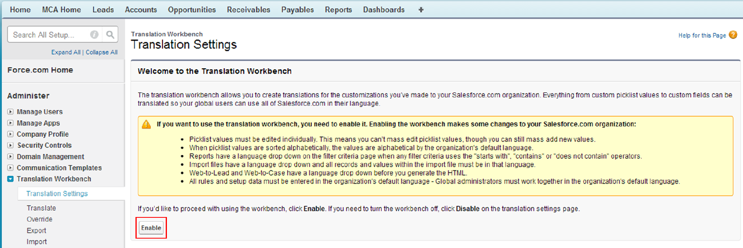

**Figure 30 – Enable Translations**

1. Go to **Custom Labels** and then click on **New Local Translation/ Overrides** button as shown in Figure 31*.*

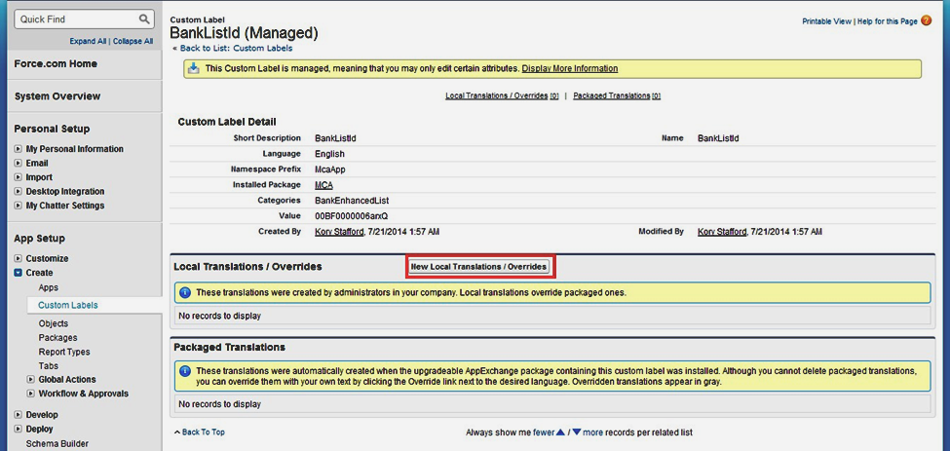

**Figure 31 – Click on New Local Translations / Overrides**

1. Enter the value for the label that you want to override in the **Translation Text** box as show in Figure 32*.*

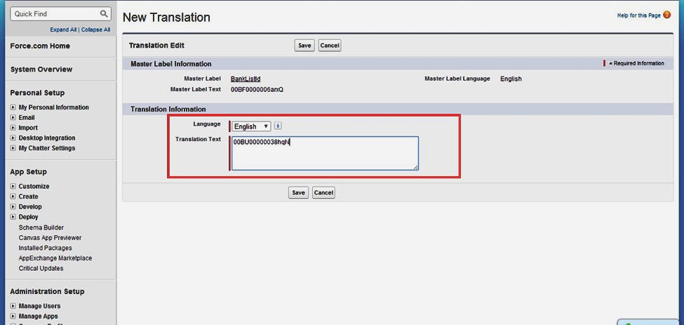

**Figure 32 – Enter the Value for the Label**

# 9 **Create record for Submission Mail Detail Object**

* Click on All tabs to create record of **Submission Email Detail** object.

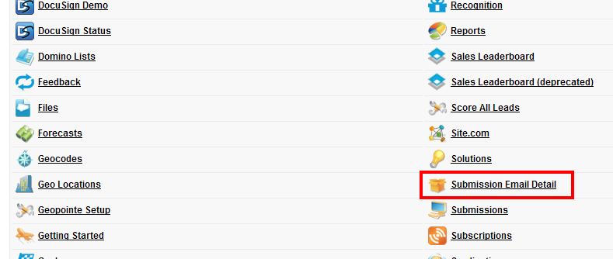

**Figure 33 – Submission Email Detail Tab**

* To create record of **Submission Email Detail** object, put the details as shown in Figure 34*.*

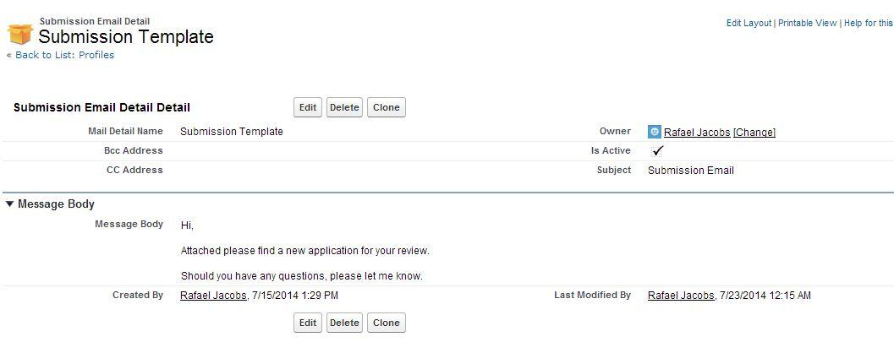

**Figure 34 – Submission Email Detail Record**

# 10 **Create a document record (Optional) to display image in Submission Email**

* Create a record of **Document**, which holds the image.

e.g. In below Image, Record of Document contains Logo Cloud My Biz, which is referred in Email send on click of **Send Without Attachment** and **Send With Attachment** button in **Submission Wizard.**

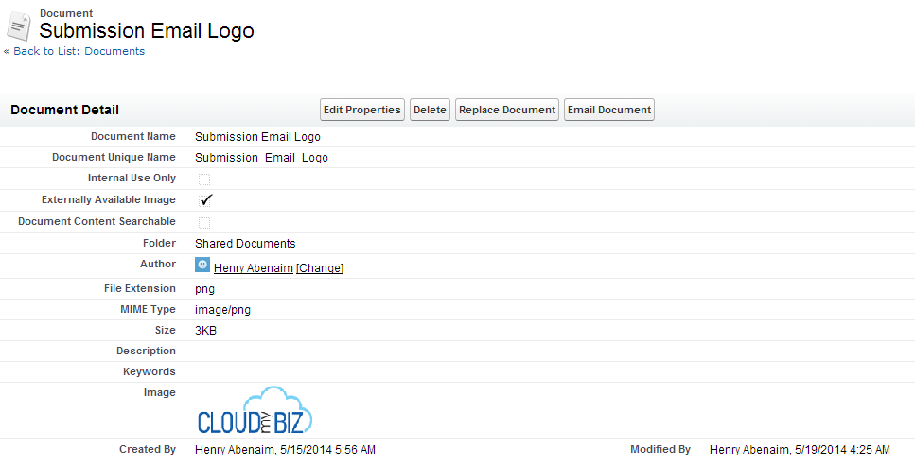

**Figure 35 – Submission Email Logo**

**10.1 Steps To Change the access level to all email-**

1. Go to **Deliverability** from Setup as shown in Figure 36

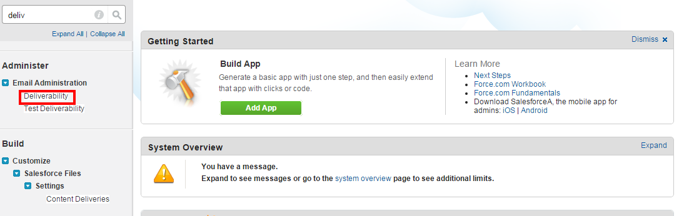

**Figure 36 – Go to Translation Settings from Setup**

1. Check if the “**Access level**” is set to “**All Email**” as shown in Figure 37

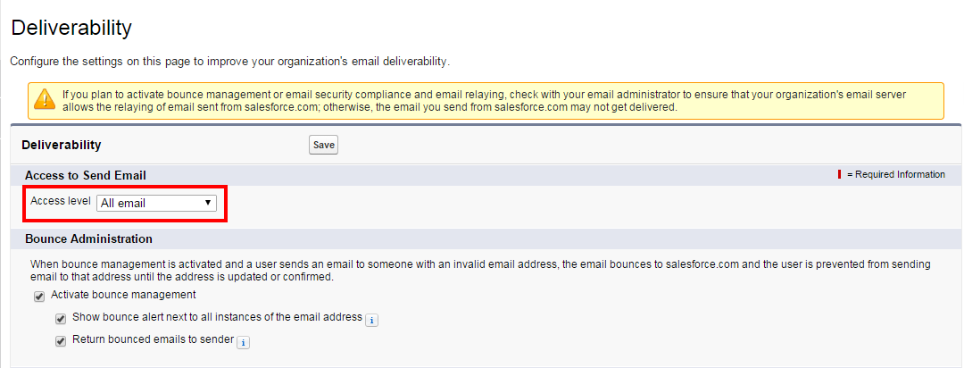

**Figure 37 – Make Access level to “All email”**

# 11 Set **Funding Application as a Default App**

1. Set Funding Application as a Default App for All Profiles and Make Custom Tab Visible
2. Go to the Profiles and make Funding App as a default app.

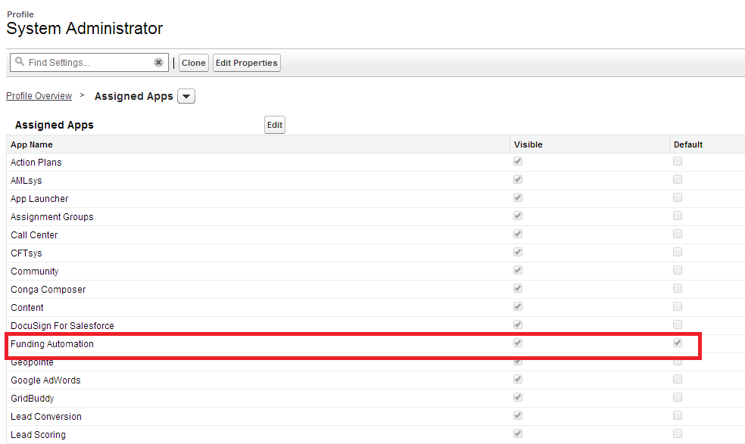

**Figure 38 – Profile Setting**

# 12 **Opportunity Stage Field Changes**

1. To display proper progress bar on Opportunity detail page, we need to match the Opportunity Stages as in Progress Bar formula field.
2. Go to the **Opportunity Stage** field and match the Stage values as mentioned below or as used in **Progress_Bar__c** formula field.
3. **Opportunity Stages -**

* Prospecting
* Application Sent
* Application In
* Application Missing Info
* Underwriting
* Approved
* Declined
* Agreement Requested
* Agreement Sent
* Agreement Signed
* Funded
* Closed Lost
* Renewal Prospecting
* Renewal Requested

**12.1 Add the picklist value :**

1. **Opportunity Type Field -**

* New Deal

# **13 Configure Custom S**ettings for Opportunity Progress Image Bar

1. To display the progress bar with appropriate stages with its corresponding colors on opportunity record.
2. **Opportunity Stages along with its corresponding colors-**

* Agreement Requested - Progress_BarColor/green.jpg
* Agreement Sent - Progress_BarColor/green.jpg
* Agreement Signed - Progress_BarColor/brown.jpg
* Application In - Progress_BarColor/blue.jpg
* Application Missing Info - Progress_BarColor/blue.jpg
* Application Sent - Progress_BarColor/orange.jpg
* Approved - Progress_BarColor/green.jpg
* Closed Lost - Progress_BarColor/red.jpg
* Declined - Progress_BarColor/red.jpg
* else - Progress_BarColor/skyblue.jpg
* Funded - Progress_BarColor/magenta1.jpg
* Prospecting - Progress_BarColor/peach.jpg
* Renewal Prospecting - Progress_BarColor/peach.jpg
* Renewal Requested - Progress_BarColor/magenta1.jpg
* Underwriting - Progress_BarColor/lightblue.jpg

# 14 **Conga Template Configuration**

1. **Funding Application Template**
   1. Upload the Funding Application PDF in Conga Template
   2. Steps:
2. Create a Funding Application PDF.
3. Open Conga Template.
4. Create a new Funding Application Template.

# 15 **Conga Email Template Configuration**

* **Offer Email Template**
  1. Create Email Template with name as 'Offer' as shown in Figure 39*.*

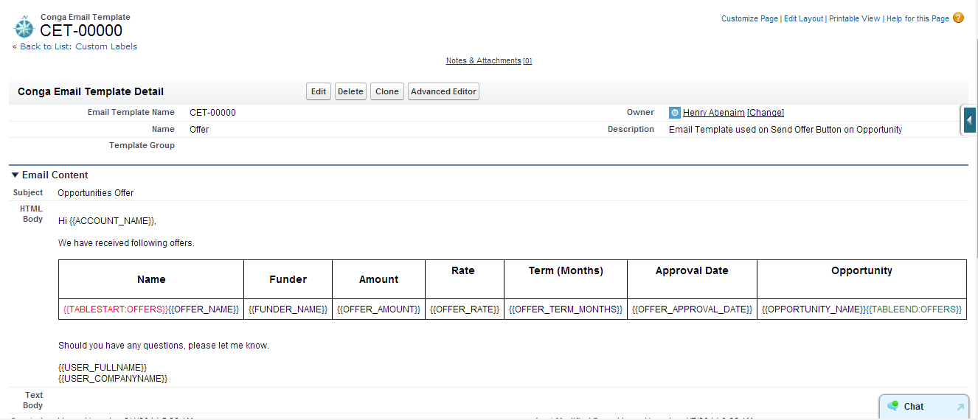

**Figure 39 – Offer Email Template**

* **Funding Application Template**
  + Create Funding Application Email Template as shown in Figure 40*.*

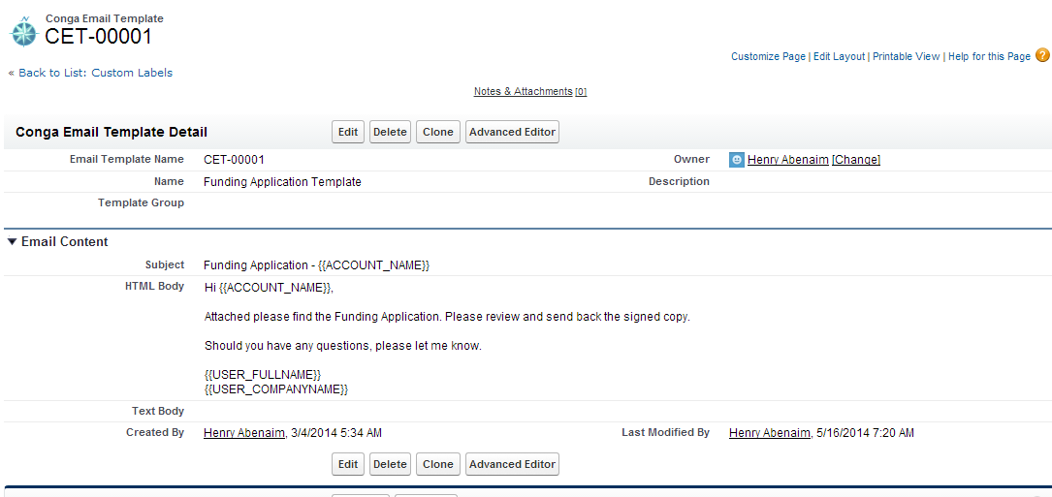

**Figure 40 – Funding Application Conga Email Template**

# 16 **Conga Queries Configuration**

* **Applicable only if there is Conga in the Org.**
  + Offer Query
* Used in Send Offer functionality.
* Create a Conga Query with Name as 'Offer'.
* Steps:

1. Click **Conga Query Builder.**

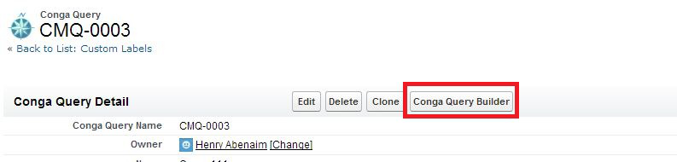

**Figure 41 – Conga Query Builder button on Conga Query**

1. Create Query as shown in Figure 40*.*

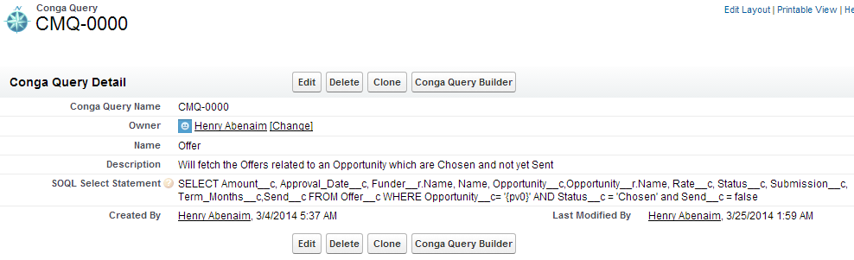

**Figure 42 – Offer Conga Query**

**NOTE –** The field names will change in the query, append the Package prefix with the fields

* + Owner1 Query
* Used in Funding Application PDF.
* Create a Conga Query as shown below.

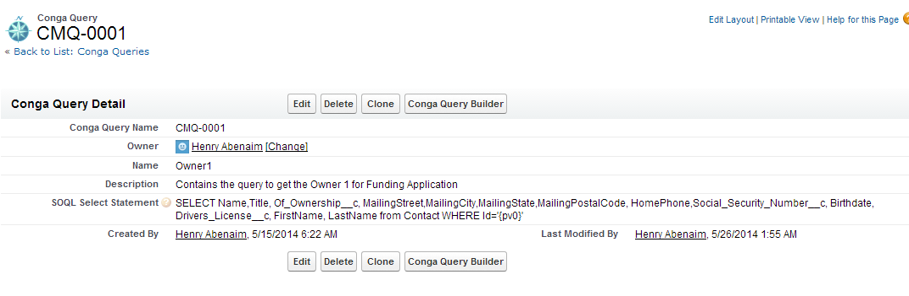

**Figure 43 – Owner1 Conga Query**

* + Owner2 Query
* Create a Conga Query as following Query.

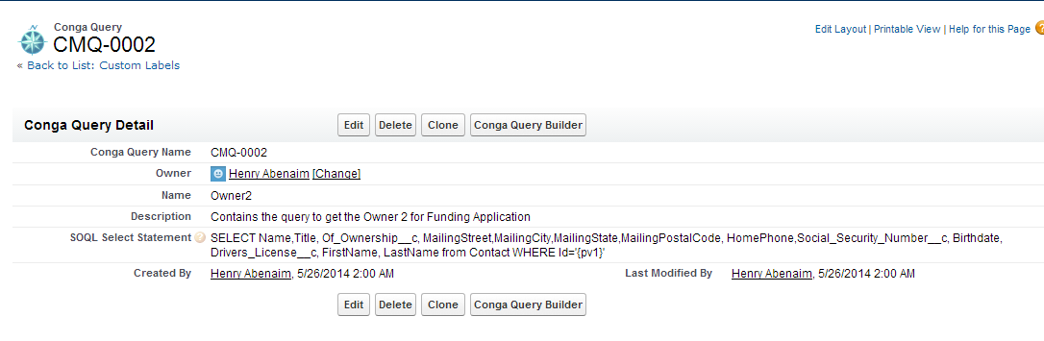

**Figure 44 – Owner2 Conga Query**